Performative Freeform Facades
Abdelaziz Awad¹ and Raghul Siva¹
¹ University College London, Gower Street, London WC1E 6BT, UK
Abstract. The project investigates the panelling of a tower with complex curved surfaces, integrating dynamic facade systems to enhance performance and adaptability. Utilizing computational techniques and reinforcement learning, the research focuses on optimizing panel design and facade responsiveness to environmental conditions. The study leverages advanced architectural geometry, parametric design, and innovative technologies to achieve sustainable and efficient tower designs. This research contributes to the field of computational design by exploring the intersection of aesthetics, engineering, and sustainability, providing a framework for future applications in architectural computation.
Keywords: Architectural Geometry, Dynamic Facades, Reinforcement Learning, Computational Design, Environmental Responsiveness.

Project Brief
This project focuses on panelling a tower with complex curved surfaces and integrating dynamic facade systems to enhance performance and adaptability. It explores computational techniques and reinforcement learning to optimize panel design and enhance facade responsiveness to environmental conditions. Key elements of the brief include:

- Tower Form Finding: Leveraging architectural geometry to develop visually dynamic and structurally sound designs.
- Surface Paneling: Ensuring efficient and aesthetically pleasing panel configurations.
- Dynamic Facades: Developing systems capable of adapting to environmental changes in real time.
- Reinforcement Learning Integration: Applying AI-driven approaches to optimize performance metrics such as shading and energy efficiency.
- Sustainability Goals: Aligning designs with environmental performance benchmarks, including solar orientation and energy load reductions.

Introduction

Architectural Geometry in Towers
Architectural geometry in tower design applies geometric principles, computational tools, and mathematics to optimize form, aesthetics, and performance. Key aspects include:
- Form Development: Transition from basic to freeform designs that leverage advanced geometric strategies like twisting and tapering to create visually dynamic and structurally sound forms. These innovations balance architectural creativity with practical considerations of stability and wind resistance.
- Surface Geometry: Efficient panelling and curvature analysis are critical to ensuring buildability and aesthetic appeal. The study employs mathematical models and computational tools to achieve this balance.
- Parametric Design and Optimization: Through parametric modelling, forms are refined to harmonize structural integrity with aesthetic goals, addressing challenges such as material efficiency and fabrication feasibility.
- Environmental Response: Sustainable design principles guide optimization for solar orientation, airflow, and shading, contributing to energy efficiency and occupant comfort.
- Structural Geometry: Advanced frameworks distribute forces evenly, enhancing resilience to environmental stresses like wind and seismic activity.
- Fabrication and Construction: Digital fabrication techniques allow for the realization of intricate geometries, optimizing material use while maintaining structural integrity.

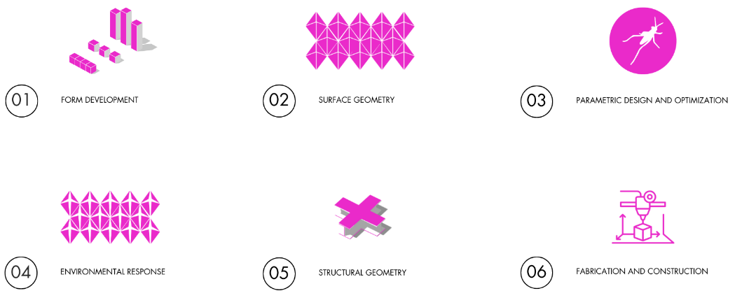
Fig. 1. Architectural Geometry Process

Adaptive Shading in Towers
Adaptive shading systems enhance building performance by optimizing energy use and improving occupant comfort. Key characteristics include:
- Sunlight Optimization: Adaptive systems adjust to minimize solar radiation while maintaining natural daylight, reducing reliance on artificial lighting.
- Environmental Responsiveness: Dynamic facades adapt in real-time to changes in solar angles, optimizing energy efficiency.
- Design Efficiency: Shading systems are designed to balance effectiveness with minimal surface area, contributing to both aesthetic and functional goals.

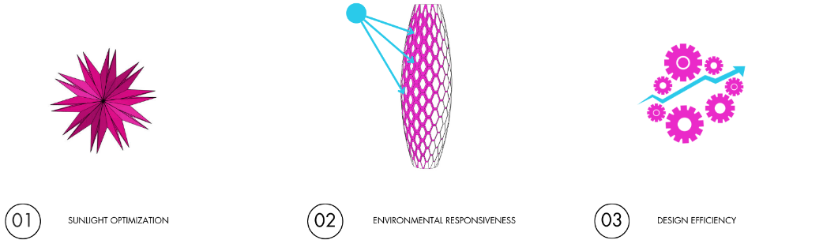
Fig. 2. Adaptive Shading Goals

Reinforcement Learning in Tower Design
Reinforcement learning (RL) integrates AI-driven optimization techniques to create adaptive, high-performance facades. This approach is characterized by:

- Dynamic Optimization: RL algorithms learn from environmental feedback to enhance shading performance, adjusting to variable conditions.
- Reduced Datasets: By training models with limited data sets (e.g., 4-8 days), RL reduces the time and resources typically required for year-long simulations.
- Autonomous Decision-Making: Systems equipped with RL can independently make decisions to achieve optimal solar control and energy efficiency, reducing the need for manual adjustments.
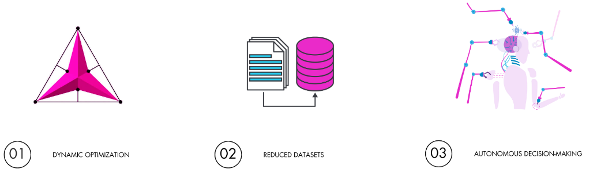
Fig. 3. Reinforcement Learning Goals

Objectives

Research Question:
How can reinforcement learning algorithms integrate with adaptive facade components to dynamically optimize environmental responsiveness and energy performance under varying conditions?

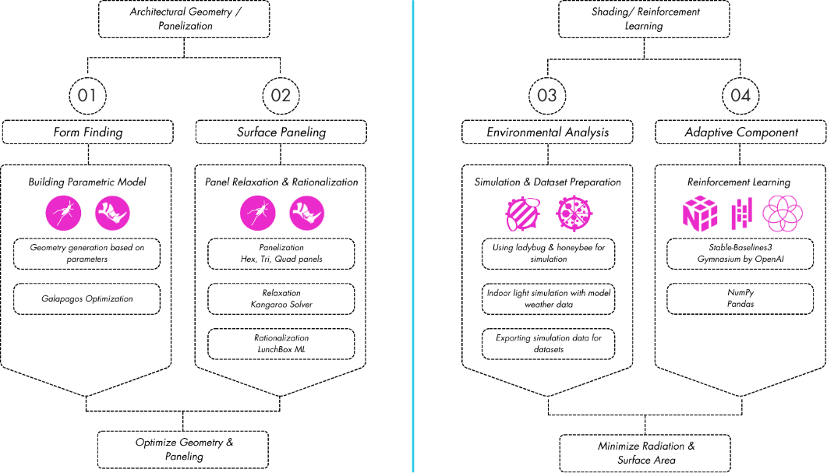
Fig. 4. Research Workflow

Research Goals:
- Minimize solar radiation while maintaining aesthetic integrity.
- Optimize panel configurations for cost and buildability.
- Enhance system adaptability through RL.

Research Toolsets:
- 3D Modelling: Grasshopper, Rhino
- Programming: Python, C#
- Simulation & Dataset Preparation: Honeybee, Ladybug
- Grasshopper Plugins: Galapagos, Mesh+, Kangaroo, Crane
- Libraries: NumPy, Pandas, PyTorch, GYM
- Post-Production: 3DS Max, Photoshop, Illustrator
- Rendering: Corona Render

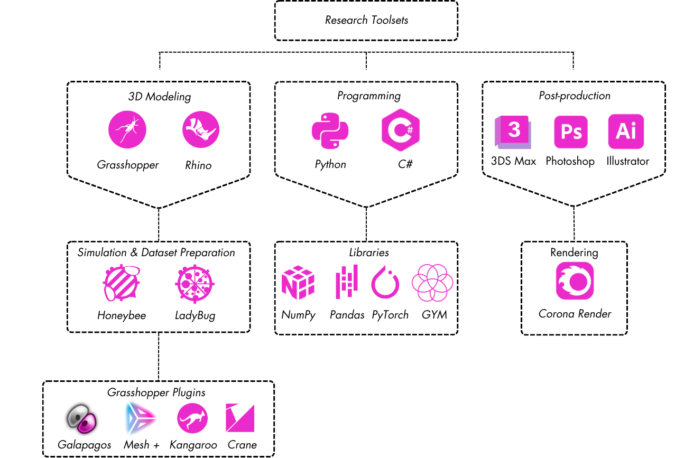
Fig. 5. Research Toolsets

Literature Review

Case Studies of Tower Geometry & Panelling

- Generali Tower (Milan): A spiral tapering form reduces wind load while maintaining aesthetic appeal. The facade features a mix of flat and cold-bent glass panels for cost-effective adaptation to curvature.
- The Gherkin (London): An aerodynamic design uses triangular panels aligned with a diagrid structure, optimizing structural and visual coherence.
- Leeza SOHO (Beijing): A twisting split-tower form utilizes quadrilateral and triangular panels, achieving daylight optimization and reduced construction complexity.

Curved Surface Classification
Curved surfaces in architectural design influence structural complexity, visual appeal, and fabrication methods. They are classified as:
- Single Curved Surfaces: Cost-effective and modular, suitable for basic geometric adaptations.
- Double Curved Surfaces: Balance aesthetic uniqueness with structural challenges, enabling innovative designs.
- Complex Curved Surfaces: Require advanced fabrication techniques but offer unparalleled aesthetic and functional possibilities.

Kinetic Facades
Case studies highlight the potential of kinetic facades:
- Kiefer Technic Showroom: Motorized aluminum panels provide dynamic shading, improving energy efficiency despite operational energy costs.
- One Ocean Thematic Pavilion: Inspired by ocean waves, its biomimetic facade optimizes solar performance but faces challenges in harsh environments.
- Arab World Institute: A pioneering responsive facade uses iris-like mechanisms to control light and solar radiation, though it has faced mechanical reliability issues over time.

Methods

Form Finding

- Geometry Introduction: The process begins with the generation of building morphology, focusing on the geometric parameters that define the tower's form. This includes the twisting angle, scaling, and the number of twists. These parameters are crucial for achieving the desired aesthetic and structural performance.
- Optimization (Galapagos): Using the Galapagos evolutionary solver, the form is optimized to minimize solar radiation. This involves running multiple iterations to find the most efficient configuration that balances aesthetic appeal with environmental performance.
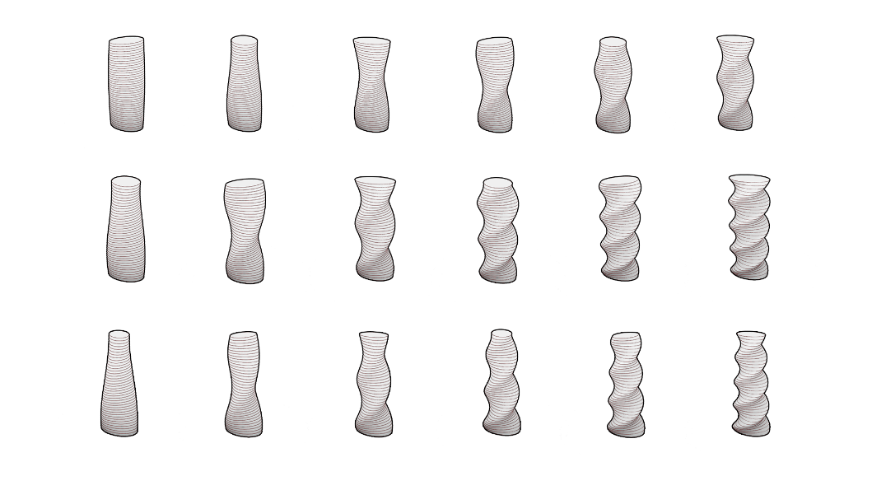
Fig. 6. Form Finding

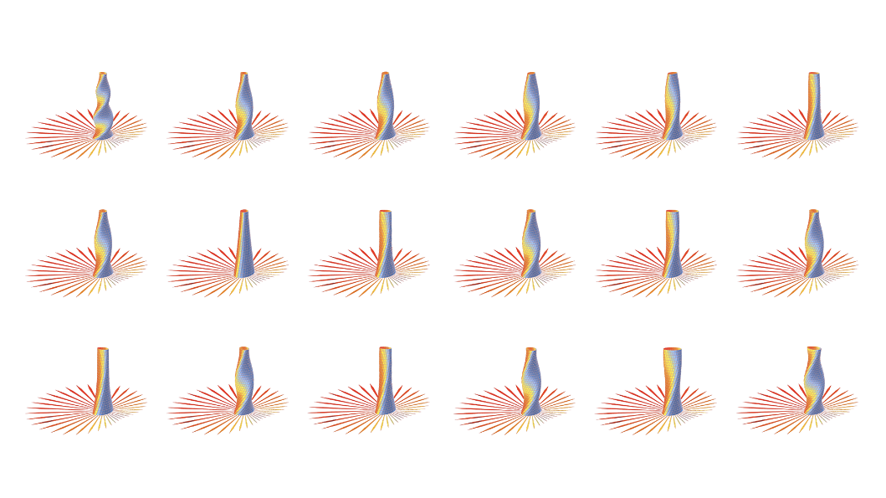
Fig. 6.1. Optimization

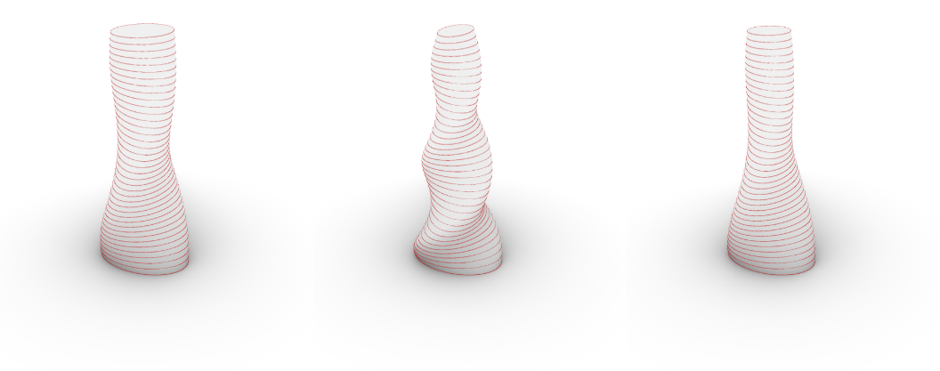
Fig. 6.1. Optimization Results

Panelization
- Constraints: The panelization process considers several constraints, including floor slab alignment and panel size. Ensuring that panels align with floor slabs is essential for structural integrity and ease of construction. Panel size is optimized to balance fabrication efficiency and material usage.
- Panel Types: Different types of panels are used based on the curvature of the surface. Hexagon, triangle, and quad panels are selected to adapt to various degrees of curvature, ensuring flexibility and minimizing distortion.

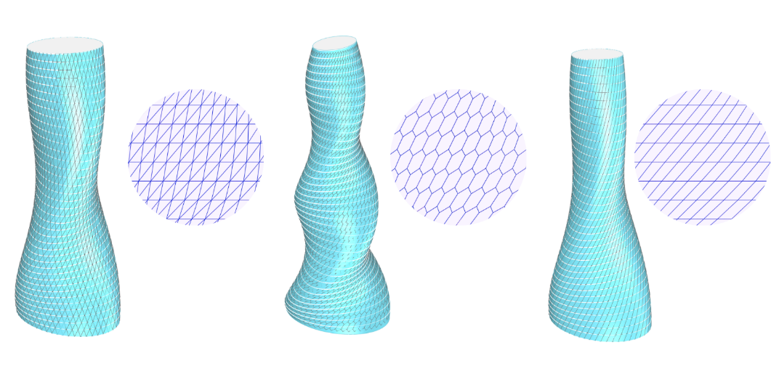
Fig7. Panelization

Panel Relaxation
- Application: Panel relaxation is applied to simplify fabrication, minimize waste, and adapt to environmental conditions. This process involves adjusting the panels to reduce stress and deformation, ensuring they fit the curved surface accurately.
- Results: The results of panel relaxation are compared before and after the process. The deviation is measured to ensure that the panels conform to the desired geometry with minimal distortion.
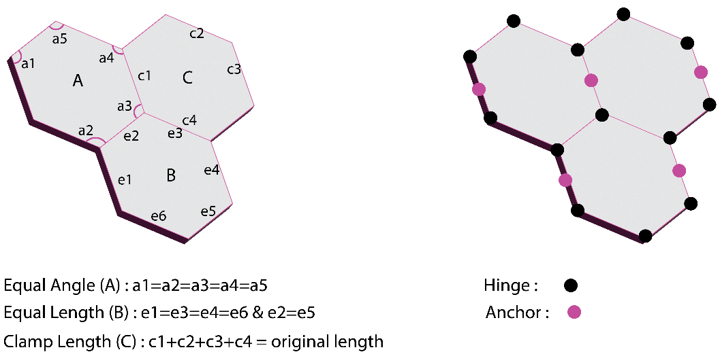
Fig. 7.1. Panel Relaxation

Panel Rationalization
- Clustering (LunchBox ML): The rationalization process uses the LunchBox ML plugin to apply Gaussian Mixture models for clustering. This involves analyzing edge length, diagonal length, and corner angles to group panels into clusters that share similar geometric properties.
- Components: The clustering results in the identification of different components, each representing a group of panels with similar characteristics. This helps in standardizing the fabrication process and reducing complexity.

Fig. 8. Clustering

Adaptive Facade
- Folding Mechanism: The adaptive facade incorporates a folding mechanism that allows panels to adjust dynamically to environmental conditions. This mechanism is crucial for optimizing solar control and energy efficiency.
- Scaling Mechanism: In addition to folding, the panels can scale in response to sun radiation. This adaptive behaviour ensures that the facade can respond to varying levels of solar exposure, enhancing the building's performance.

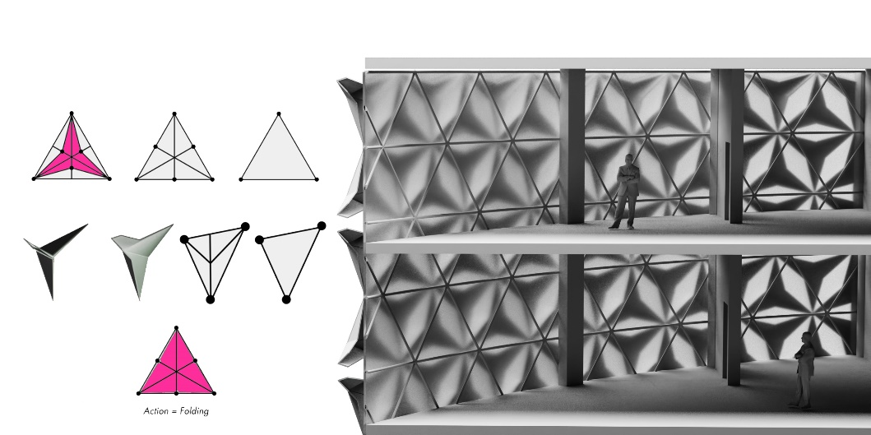
Fig. 9. Folding Adaptive Facade

Environmental Analysis
- Simulation: Environmental analysis is conducted using simulation tools like Ladybug and Honeybee. These tools simulate indoor light conditions and generate datasets for reinforcement learning. The simulation helps in understanding how the facade interacts with environmental factors such as sunlight and wind.

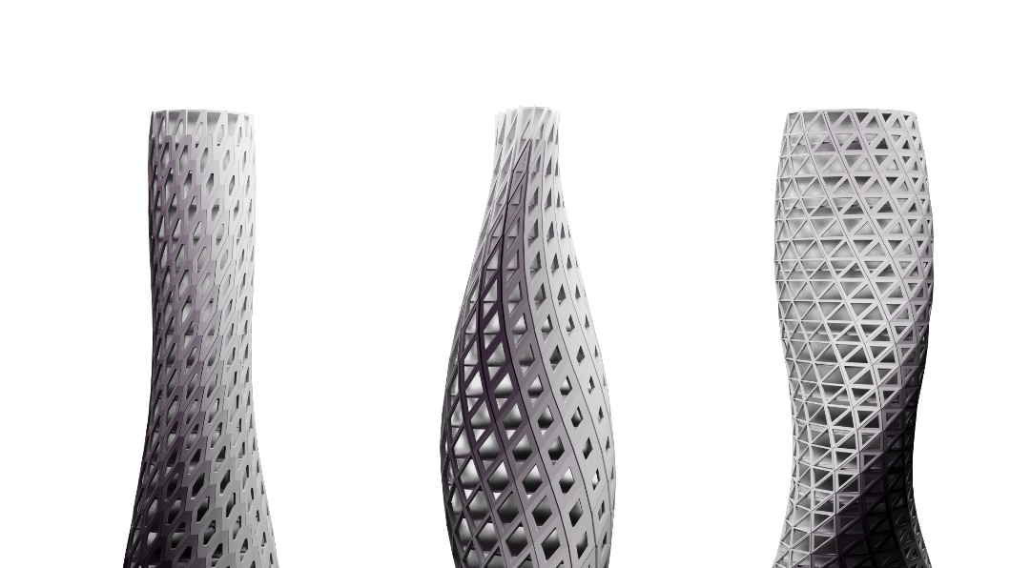
Fig. 10. Parametric Panels According to The Environmental Analysis

Reinforcement Learning
- Reinforcement Learning Framework: The reinforcement learning framework used in this project involves training an agent to optimize the facade's adaptive components. The agent learns to adjust the facade panels in real-time to respond to environmental changes, such as varying solar radiation and temperature.
- Training Process: The training process involves using a reinforcement learning algorithm, such as Proximal Policy Optimization (PPO), implemented with libraries like Stable-Baselines3. The agent interacts with a simulated environment, receiving rewards based on the performance of the facade in terms of minimizing solar radiation and surface area.
- Simulation and Dataset Preparation: The simulation environment is created using tools like Rhino and Grasshopper, with plugins such as Ladybug and Honeybee for environmental analysis. The data generated from these simulations is used to train the reinforcement learning agent.
- Optimization Goals: The primary goals of the reinforcement learning agent are to minimize solar radiation and surface area while maximizing occupant comfort. The agent learns to balance these objectives through continuous interaction with the simulation environment.
- Actions and Observations: The actions taken by the agent include scaling and folding the panels. The observations used by the agent include the sun vector radiation, which informs the agent about the current environmental conditions.

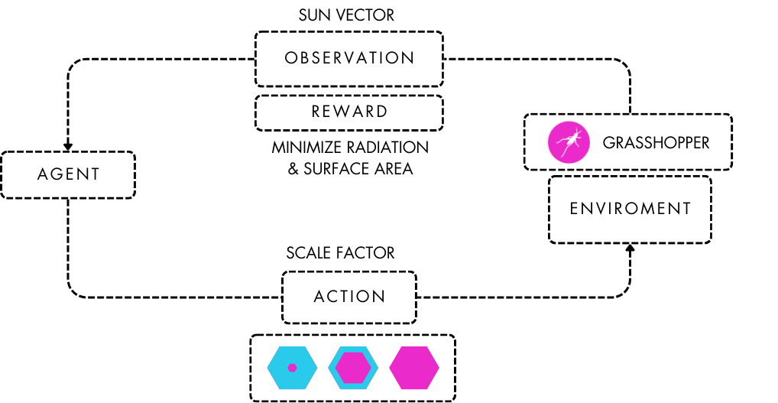
Fig. 11. RL Model Diagram

Results

Panel Rationalization

- Clustering Analysis: The clustering analysis reveals how panels can be grouped based on their geometric properties. This rationalization process helps in standardizing the fabrication and installation processes, reducing costs and complexity.
- Components: The analysis identifies several components, each representing a cluster of panels with similar characteristics. This standardization is crucial for efficient fabrication and assembly.

Adaptive Panels
- Sun Radiation Response: The adaptive panels are tested for their response to sun radiation. The panels adjust their configuration dynamically to optimize solar control, reducing energy loads and enhancing comfort.
- Testing Animation: The testing animation involves three different towers, each equipped with a different type of adaptive panel: hexagonal, diamond, and triangular. These animations demonstrate how each type of panel responds to environmental conditions, showcasing their dynamic behavior and effectiveness in optimizing solar control and energy efficiency.

Model Training
- Graphs: The training process is visualized through graphs that show training loss, value loss, and standard deviation. These graphs help in understanding the model's learning progress and performance.
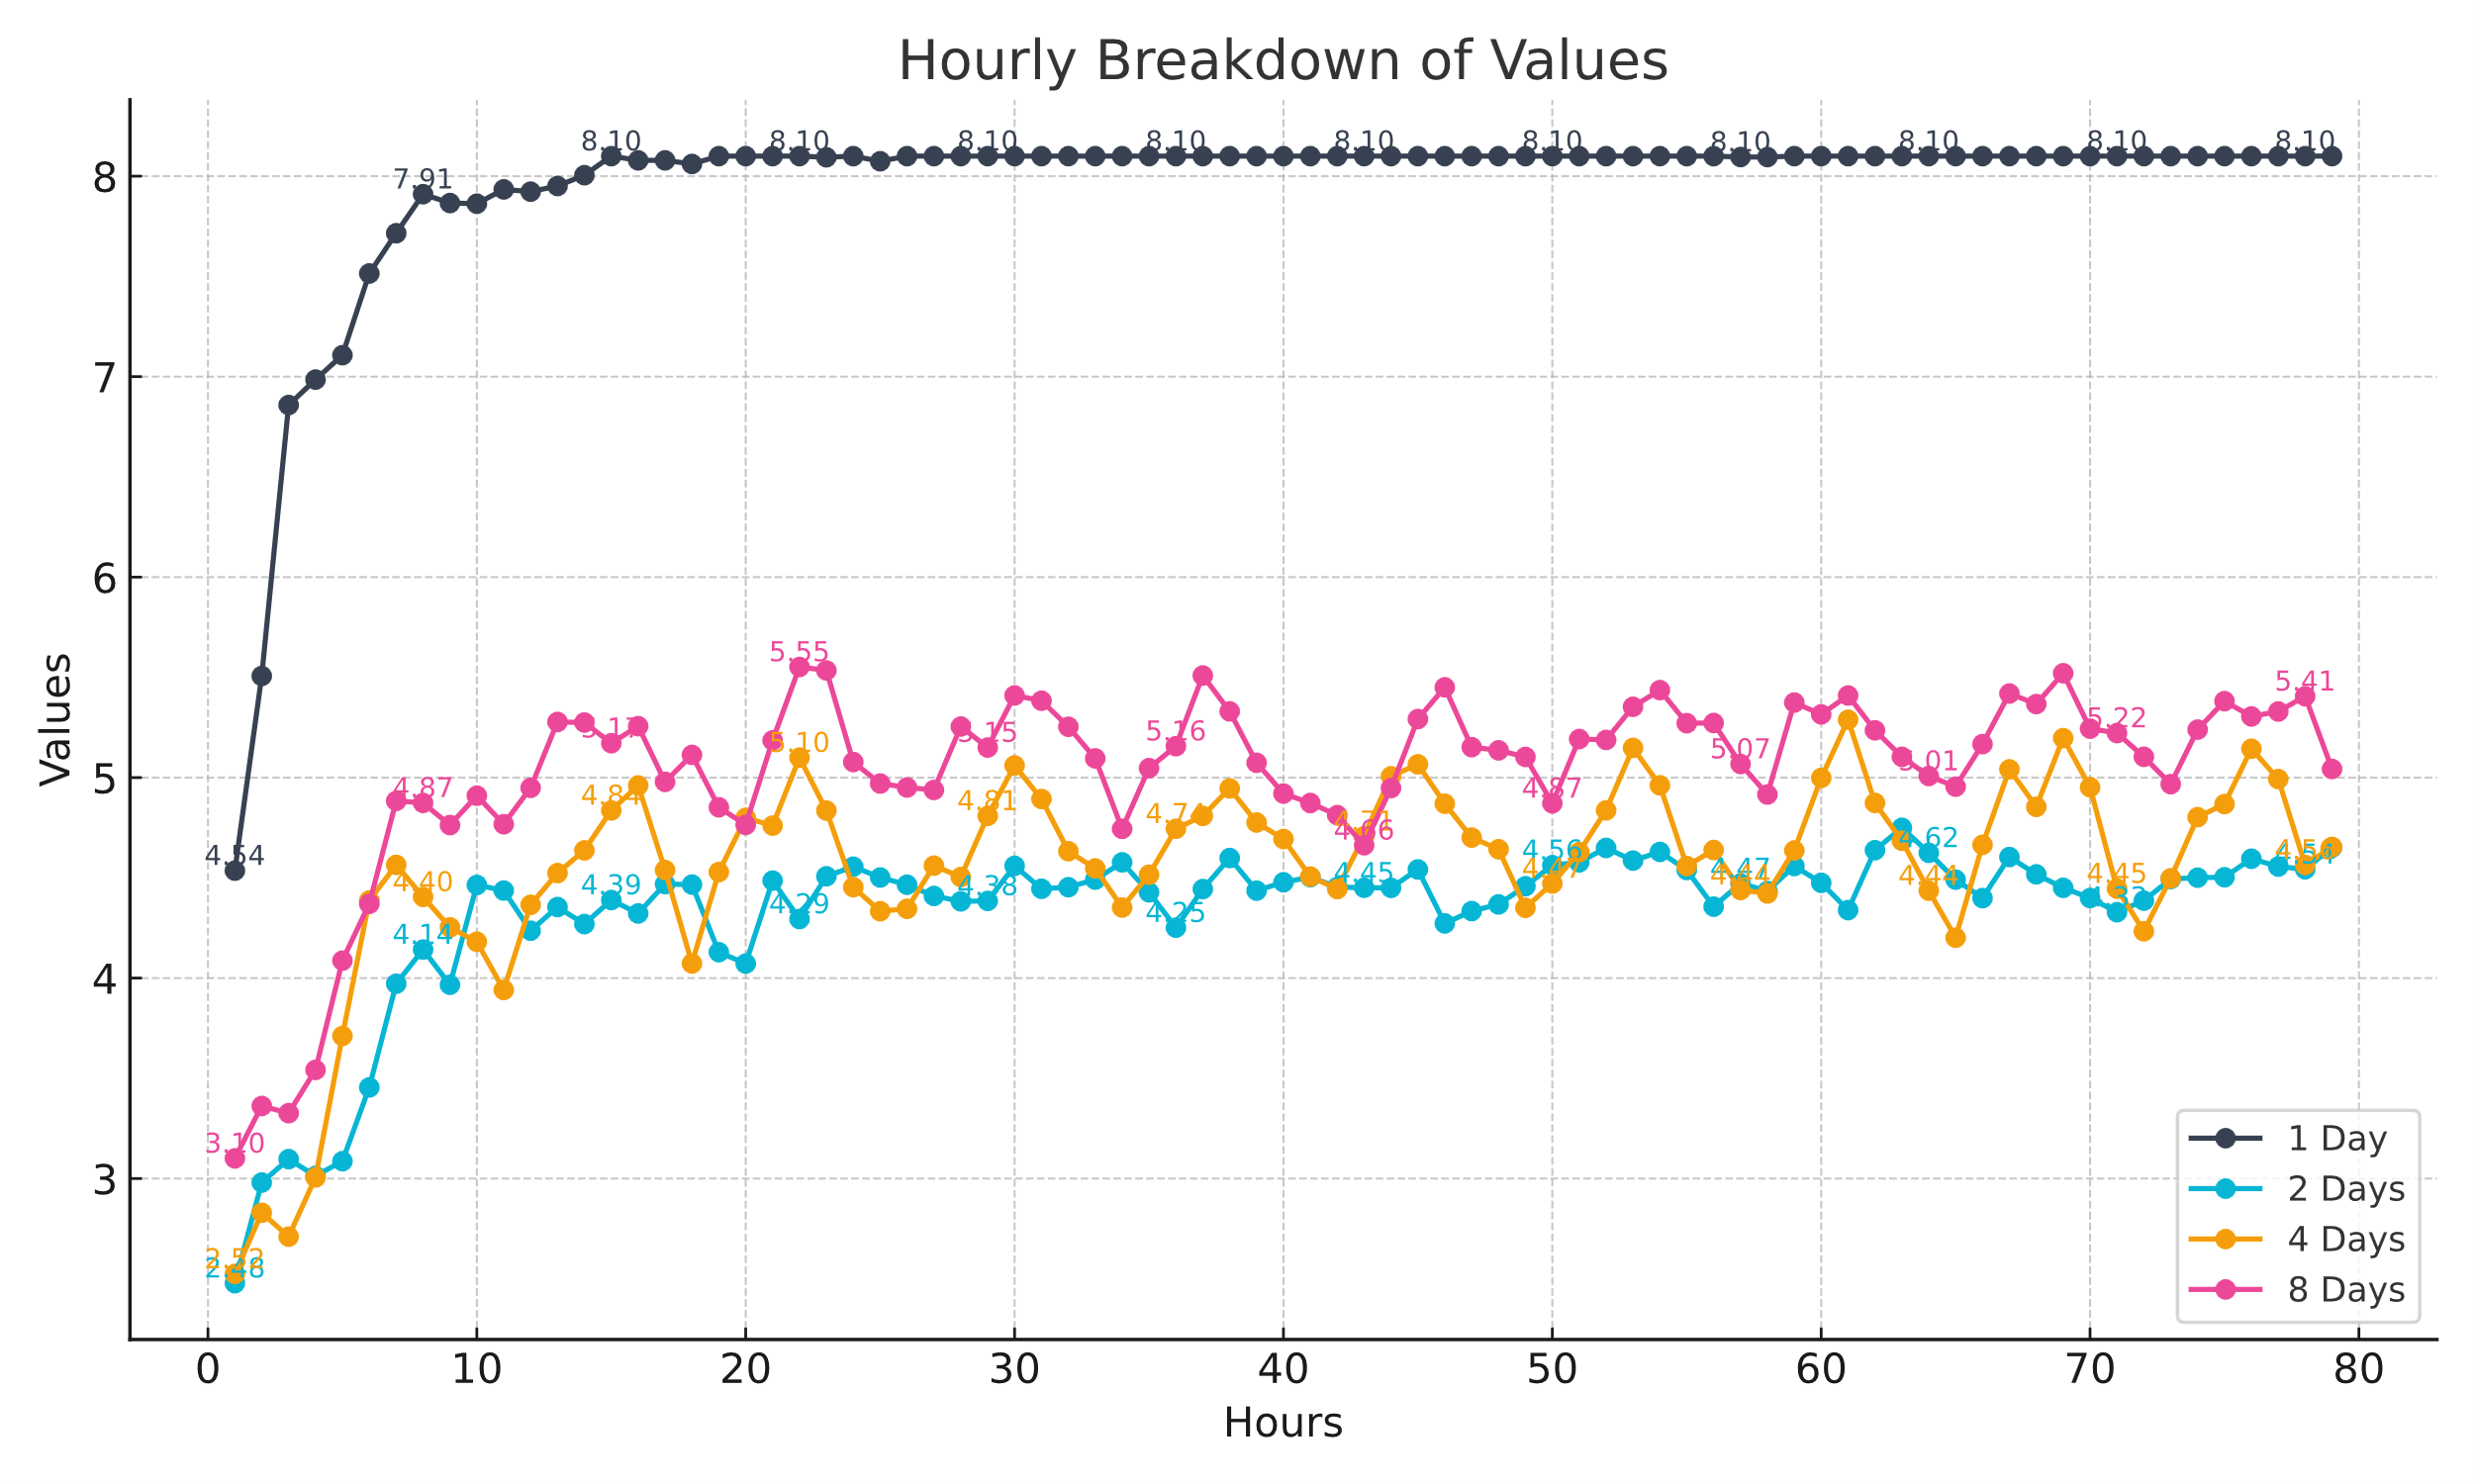
Fig. 12. Training Results

- Testing on a Tower: The trained model is applied to a tower structure to test its effectiveness. The results show how the adaptive facade improves the building's performance in real-world conditions.

References

- Qiu, S., Li, Z., Li, Z., Li, J., Long, S., & Li, X. (2020). Model-free control method based on reinforcement learning for building cooling water systems: Validation by measured data-based simulation. Energy and Buildings, 218, 110055. https://doi.org/10.1016/j.enbuild.2020.110055
- Mollaeiubli Takhmasib, Hyuk Jae Lee, Hwang Yi: Machine-learned kinetic Façade: Construction and artificial intelligence enabled predictive control for visual comfort. Automation in Construction, Volume 156, 2023, 105093, ISSN 0926-5805. https://doi.org/10.1016/j.autcon.2023.105093
- Mi-jin Kim, Baek-gyeom Kim, Je-sung Koh, Hwang Yi: Flexural biomimetic responsive building façade using a hybrid soft robot actuator and fabric membrane. Automation in Construction, Volume 145, 2023, 104660, ISSN 0926-5805. https://doi.org/10.1016/j.autcon.2022.104660
- Sida Dai, Michael Kleiss, Mostafa Alani, Nyoman Pebryani: Reinforcement Learning-Based Generative Design Methodology for Kinetic Facade. CAADRIA proceedings, 2023. https://www.researchgate.net/publication/362180515_Reinforcement_Learning-Based_Generative_Design_Methodology_for_Kinetic_Facade
- Ammar Alammar, Wassim Jabi: Predicting cooling energy demands of adaptive facades using artificial neural network. Presented at: The 13th annual Symposium on Simulation for Architecture and Urban Design (SimAUD), 2022. https://orca.cardiff.ac.uk/id/eprint/151380/1/96_Paper_PREDICTING-COOLING-ENERGY-DEMANDS-OF-ADAPTIVE-FACADES-USING-ARTIFICIAL-NEURAL-NETWORK.pdf
- Author, F.: Article title. Journal of Facade Design and Engineering, Volume 7, 2020, 45-56. https://jfde.eu/index.php/jfde/article/view/119/119
- Jaafar Ahmad Ibrahim, Halil Zafer Alibaba: Kinetic Façade as a Tool for Energy Efficiency. Research Publish, 2020. https://www.researchpublish.com/upload/book/KINETIC%20FACADE%20AS%20A%20TOOL-8194.pdf
- Yuanyuan Li, Chenyu Huang, Gengjia Zhang, Jiawei Yao: Machine Learning Modeling and Genetic Optimization of Adaptive Building Facade Towards the Light Environment. ResearchGate, 2023. https://www.researchgate.net/publication/362171740_Machine_Learning_Modeling_and_Genetic_Optimization_of_Adaptive_Building_Facade_Towards_the_Light_Environment
- Case Studies in Cost-Optimized Paneling of Architectural Freeform Surfaces Michael Eigensatz ETH Zurich and EPFL Mario Deuss EPFL Alex Schiftner Evolute and TU Wien Martin Kilian Evolute and TU Wien Niloy J. Mitra KAUST Helmut Pottmann Evolute and KAUST Mark Pauly EPFL
http://vecg.cs.ucl.ac.uk/Projects/SmartGeometry/paneling_aag/paper_docs/paneling_aag10.pdf
- Paneling Architectural Freeform Surfaces Michael Eigensatz ETH Zurich / EPFL Martin Kilian Alexander Schiftner Evolute / TU Wien Niloy J. Mitra KAUST / IIT Delhi Helmut Pottmann KAUST / TU Wien Mark Pauly EPFL
https://graphics.stanford.edu/~niloy/research/paneling/paper_docs/panelization_sigg10_large.pdf
- Triangle Surfaces with Discrete Equivalence Classes Mayank Singh∗ Texas A&M University Scott Schaefer† Texas A&M University
https://people.engr.tamu.edu/schaefer/research/equivalence.pdf
- Geometry of Architectural Freeform Structures Helmut Pottmann1 , Alexander Schiftner1,2 , Johannes Wallner3 1 TU Wien 2 Evolute GmbH, Wien 3 TU Graz
https://www.geometrie.tugraz.at/wallner/arch-imn.pdf
- Geometry of Multi-layer Freeform Structures for Architecture Helmut Pottmann∗ TU Wien Yang Liu † TU Wien / Univ. of Hong Kong Johannes Wallner‡ TU Graz Alexander Bobenko§ TU Berlin Wenping Wang† Univ. of Hong Kong
https://people.eecs.berkeley.edu/~sequin/CS285/PAPERS/Pottmann_FrFrm_arch.pdf
- Packing circles and spheres on surfaces Alexander Schiftner∗ Evolute, TU Wien Mathias Hobinger ¨ † TU Wien Johannes Wallner‡ TU Graz Helmut Pottmann§ KAUST, TU Wien
https://www.geometrie.tugraz.at/wallner/packing.pdf

